**Computer vision based warning system of learners engagement shift in online learning platforms**

**Abstract - The technique of measuring engagement is used to determine whether or not people are giving attention to their circumstances. "Student engagement" refers to how much students participate intellectually and emotionally in their classwork, and it can be evaluated in a variety of ways. Defining a clear procedure for assessing and comprehending patterns in engagement measurement can help to improve the figures significantly. This can be done to assist with the process of improving the figures. This research presents a comprehensive analysis of all previous approaches to quantifying the degree of user involvement. More concrete methods, such as multimodal methods, have been combined with more abstract methods, such as simple face expression identification. A multimodal approach considers a variety of different inputs to arrive at a result that is both rational and robust. These inputs could range from a person's facial emotions to their skeleton structure. Numerous papers have demonstrated that facial expressions can be detected in a variety of ways.**

**Keywords - CNN, Image Classification, Deep Learning, SVM, ML.**

**I. INTRODUCTION**

The study of extracting useful, evaluating, and perceiving valuable information from a single

image or a sequence of images is known as computer vision.[1] Schools could use an image recognition programme and computer vision to electronically capture attendance. Not only will this save teachers time by automatically recording attendance, but it will also include an emotion analysis tool to provide school faculty and staff with more information on students and early warning of major shifts in their psychological state. [2] The information gathered may then be utilised

by teachers and staff to assess student involvement and emotion.

The degree of engagement or disengagement could be determined using facial features, head movements, computer vision, and gaze rhythms [3]. Image classification, localisation, and emotion analysis are just a few of the many computer vision characteristics that could assist in student participation in class [4]. In addition to facial expressions, skeleton structures may be analysed to evaluate the participant's degree of engagement [5].

In this work, we will compare the effectiveness of face emotion recognition in detecting student engagement. By the use of these previous papers we have come across the proposed methods and compared them in order to create and come up with a method with superior accuracy and features.

**II. GROUNDWORK**

**A. Dataset Collection**

Having a sizable dataset is necessary for face and emotion recognition. The dataset needs to be substantial enough to train a model that can identify every visual emotion. A fresh or pre-existing collection could serve as the dataset's basis. Fig 1 is an illustration of an emotion dataset.

**B. Dataset Pre-Processing**

The ability to identify the emotion being sent by a face in an image by using only the central facial features—such as the nose, eyes, and mouth—is a significant advancement in the classification of emotions. This is because the face's primary features are all that are required for it to function in this way. As a result, a variety of methods and algorithms are employed to discover faces inside the image.

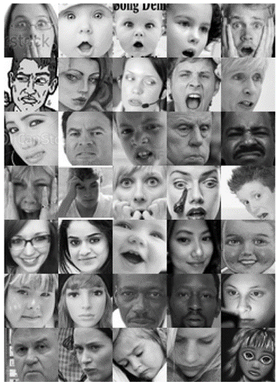

**Fig 1. Dataset with multiple emotions sample**

**C. Feature Extraction**

Extraction of feature points is required for face detection. There are numerous techniques for extracting feature points. Examples include Linear Discriminant Analysis (LDA), Scale Invariant Feature Transform (SIFT), Moments Speeded-Up Robust Features (SURF), and Gabor wavelets. Gabor Wavelets are reliable photometric measurers of feature vectors. SURF concentrates on a few core concepts.

**D. Classification**

When categorising emotions, think about "natural" and "random" classifiers. The most widely used random classifiers are KNN, SVM, and Random Forest. Based on visual qualities, these techniques classify emotions including fear, rage, surprise, disgust, happiness, sorrow, and neutrality.

**III. LITERATURE REVIEW**

Zeyad Abdulhameed et al[1] used CNN pre-training models to determine student eye-gaze participation. MobileNet, trained on ImageNet, is a popular image classification model. For the second layer's output estimate of Engagement or Disengagement, the softmax function was used..During training, RMS prop reduced error. To prevent overfitting, machine learning used dropout and batch-normalisation.

The below image figuratively represents the process of feature extraction using MobileNet Model architecture.

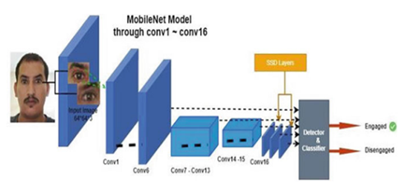

**Fig 2.:MobileNet model architecture[1]**

Chakradhar & Kumar et al[2]suggested CNN architecture has numerous convolution-2D, max-pooling-2D, flatten, hidden, and softmax layers.

**The Fig 3 shows the CNN architecture for image recognition represented figuratively.**

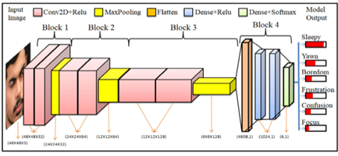

**Fig 3.Model architecture of CNN**

● Face image extraction

A multi-task cascade convolution neural network (MTCNN) was used as a pre-trained face recognition model.

● Head pose detection

The head position identification process eliminates any non-frontal faces from either the input image, including left-skewed, right-skewed, upward, and downward faces.

Y. -Y. Ou et al[3]used SFPs to observe human expression. Identity is confirmed by body type and facial skeleton. Local Binary Pattern Histogram measures facial light and shadow (LBPH). The skeleton dictates body type.Emotion recognition uses facial landmarks and HC-SVM. SFPs are used to monitor facial action units during emotion recognition. SFPs use API facial landmarks (API). Face texture feature extraction and identity recognition use LBPH and KNN. Joint count determines body type.

The below image [Fig 4] represents the architecture of Support Vector Machine (also pronounced as SVM) for action unit recognition with hierarchical-coherence.

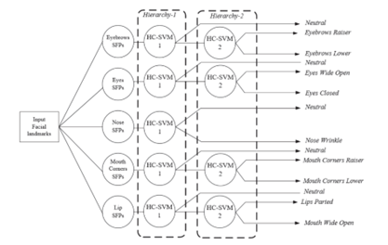

**Fig 4.. The architecture of Hierarchical-Coherence Support Vector Machine for action unit recognition.[3]**

S. Deniz et al[4]suggestedOpenCV, a facial recognition library, is this program's main dependency. Haar and LBPH are implemented in OpenCV. Haar identifies faces and objects. First, the video is grayscale. Haar characteristics are used to evaluate facial highlights and shadows. For facial identification, Haar characteristics are required.. EigenFaces and FisherFaces use LBPH for facial recognition. LBPH studies texture and structure in tiny pixel regions for feature extraction. Fury, disdain, disgust, fear, happiness, indifferent, melancholy, and astonishment can be detected. The application only monitors happiness, sadness, wrath, and neutrality despite detecting eight.. Fig 5 shows something figuratively represented as the input and their output at each level of the program module.

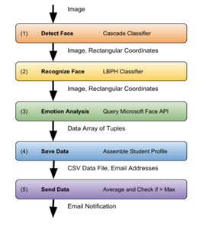

**Fig 5. Representation of program module[4]**

P. Chiranjeevi et al[5] suggested that each input shape is aligned using Procrustes analysis. To accommodate for CLM alignment difficulties caused by posture changes, a statistical texture model for each KE point and use structural similarity to identify change. This section outlines our algorithm-Procrustes analysis

* CLM to track N facial feature points in each frame.

● Emotional highlights:

● KEYPOINT tracking

● Patch Representation

● Multi-neighbor structural comparison

● Fusion of KE Point Pair Distances

After detecting the change status in each place (cheek, eyebrow, and mouth), the proposed technique uses only the appropriate AUs for emotion classification, unlike existing ER systems that supply the features to all AUs .

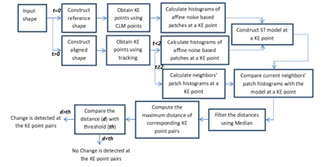

**Fig 6. Illustrative diagram of the pre-processor.[5]**

A. V. Iyer et al[6] in their study have used the following techniques for Face detection:

● Canny Edge Identification

● Viola Jones

Voice, face, and body language can all convey emotions. This study examines face expressions as identifiers.

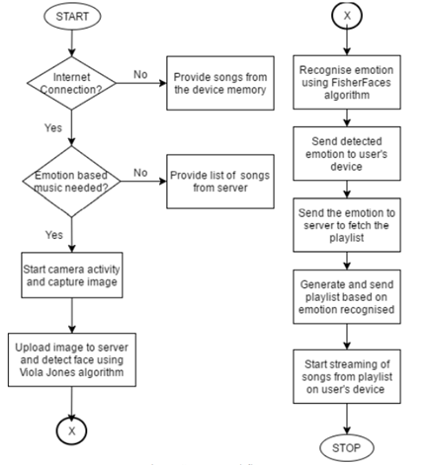

**Fig 7 . System workflow[6]**

Apicella et al. [7] describe an EEG-based technique to identify emotional and cognitive involvement during a learning task. Two Support Vector Machine (SVM) classifiers receive a collection of characteristics from two Common Spatial Pattern (CSP) algorithms, each trained to evaluate Cognitive and Emotional Engagement. Only for cross-subject data is a baseline removal followed by a TCA process provided during the classifier's training phase. Fig 8 below is the figurative explanation for the assessment of engagement.

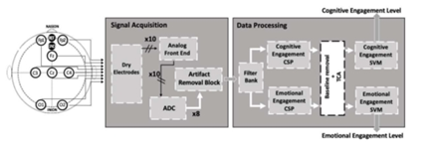

**Fig 8. Student Engagement architecture**

Mustafa and Zdemir et al. [8] used SECS for image recognition, a plot of directed gradients for face recognition, PnP for head pose estimation, and SVM for classification. The "Engaged" term or "Not Engaged" term labels on the screenshots are indeed the segmentation results for real-time student engagement produced by the program's SVM machine learning algorithm for each frame.

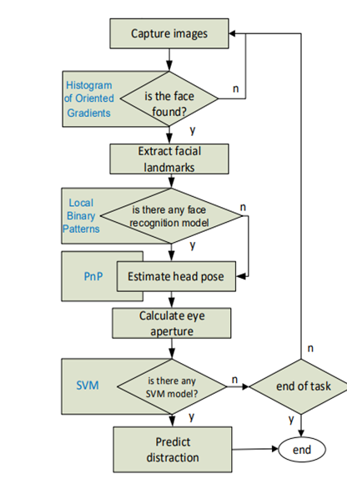

**Fig 9. Flowchart of main module of SECS[8]**

Ayouni S et al [9] used a method based on the student's Grade Point Average (GPA) and the instructor's evaluation. It contains the categorical target variable (class), which reflects the level of student participation based on GPA. Classification prediction models like DT or Decision Tree classification, SVM or the support vector machine and the ANN or artificial neural network are used.[9]

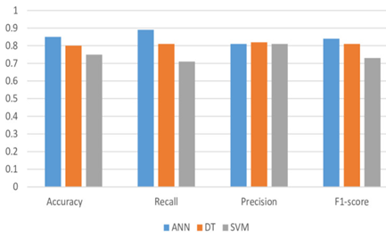

**Fig 10..Performance metrics of ANN, DT and SVM.[9]**

Ali Abedi et al[10] utilised a 3D CNN, spatiotemporal characteristics are retrieved from videos. The retrieved features from 3D CNN are passed to ResNet, whose output is then passed to TCN for temporal analysis. In our design, ResNetis used to extract spatial information from frames, and the outputs of ResNet are passed to TCN for temporal analysis.

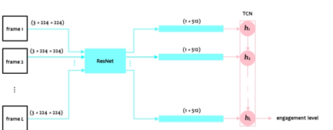

**Fig 11. The end-to-end architecture, ResNet+TCN, for engagement level detection[10]**

So, for our study, we decided to build a custom CNN architecture to determine whether or not students are engaged in a class.The model that we came up with is highly rudimentary and decides whether a student is engaged or not based on only the facial expressions.

The growth of virtualization technology has led to an increase in the number of VMs and data centres, resulting in duplication of data for various purposes[11]. Data Deduplication is a technique that detects and eliminates duplicate data, reducing the consumption of resources like storage space and network bandwidth[11].

Cloud computing enables resource sharing through virtualization, which optimises computer system utilisation[12]. Virtual machine migration addresses load balancing and power consumption issues in the cloud environment[12].

Virtual machine migration offers advantages such as fault tolerance and load balancing[13]. The pre-copy approach is often used in live VM migration, but it results in longer migration time due to transfer of duplicate memory pages. The proposed algorithm, DedupMR, uses MapReduce to perform parallel deduplication of memory pages, resulting in reduced migration time and downtime[13]. The MapReduce technique processes data in parallel, and duplicated pages were reduced by up to 29% in this study.

Human re-identification (Re-ID) is gaining attention for recognizing suspicious people in security camera footage[14]. However, individual Re-ID poses a security risk for innocent individuals. The proposed technique uses a Haar cascade to ensure confidentiality and safety while preserving individual re-identification in privatised camera videos. This approach addresses computational and memory expenses while ensuring individual safety.

The ResNet50 (a human detection and classification algorithm using Faster R-CNN) is optimised using stochastic gradient descent with momentum (SGDM) for better accuracy and faster training time[15]. This algorithm is important for applications such as self-driving cars, surveillance systems and gender classification[15].

The paper offers a method for human re-identification that can be used to spot suspects in security camera footage. However, this method might jeopardise the privacy of uninvolved parties who appear in the footage. Suggestions for confidentiality-preserving methods that ensure the safety of identified people while protecting their privacy in order to address this[16].

Multimodal biometric systems are more reliable and secure than unimodal systems due to their ability to use more than one biometric trait to identify a person[17]. A new Enhanced Local Line Binary Pattern (ELLBP) method is proposed to extract features from ear and fingerprint, improving recognition rate and providing a more reliable multimodal system[17]. Results from experiments using publicly available databases show that the enhanced method outperforms earlier methods, including unimodal systems[17].

A Virtual Private Network (VPN) allows users to securely connect to a network without revealing their IP address[18]. This technology was initially developed to connect remote users to a secure institutional network. VPN is widely used, but few studies have been conducted on it, and it is often used for illegal activities in the cyber world. Hackers and crackers use VPN to remain anonymous while committing crimes, making it difficult for cyber security experts to track them[18].

The increased usage of multimedia contents has led to the creation of large image and video databases[19]. Content-Based Image Retrieval (CBIR) systems have been developed to efficiently search through these databases, but are limited by the semantic gap. User feedback, or relevance feedback, can be used to reduce the semantic gap and improve the accuracy of retrieval results[19].

By computing the influence of VM deployment and choosing the least-effective solution, the strategy achieves better load balancing and reduces migration. Experimental results show that this approach improves resources utilisation and load balancing in both stable and variant system loads, compared to traditional algorithms[20].

A paradigm known as "cloud computing" allocates resources from a pool to users based on demand in order to meet their needs[21]. Live virtual machine migration can address power consumption and load balancing issues by moving virtual machines from overloaded to underloaded hosts. This process, also known as VM migration, can be performed with the virtual machines still powered on[21].

**IV. PROPOSED WORK**

So, for our study, we decided to build a custom CNN architecture to determine whether or not students are engaged in a class.The model that we came up with is highly rudimentary and decides whether a student is engaged or not based on only the facial expressions.

The target is to build a web application that simulates the operation of a platform for holding online meetings.

The goal of this project is to accomplish the integration of the custom made CNN model into the application so that real-time data can be obtained from online meetings.

The online meet application would replicate in some areas, the existing real world teachers. Whereas some features would be creatively made.

Coming to the backend we would use WebRTC, a Javascript Library which makes it possible to incorporate real time communication. We will use Deep Learning in the backend, which anyway does not communicate with the front end, and only ever talks to the backend.

We use ReLU, a rectified linear unit in order to provide non linearity to the model.

Towards the conclusion of Neural networks, we strive to find one or more completely linked layers. When building a neural network, the softmax activation function is typically implemented in the last completely connected layer, as it helps in producing the probability between 0 and 1 for each of the classes that the model is attempting to predict.

The identification of emotions will serve as the foundation for our first set of models, and we will use them to develop a metric for gauging levels of user engagement. This strategy will descriptively quickly be elevated to a higher level when an original engagement detection convolutional neural network would be conceived of as a potential improvement.

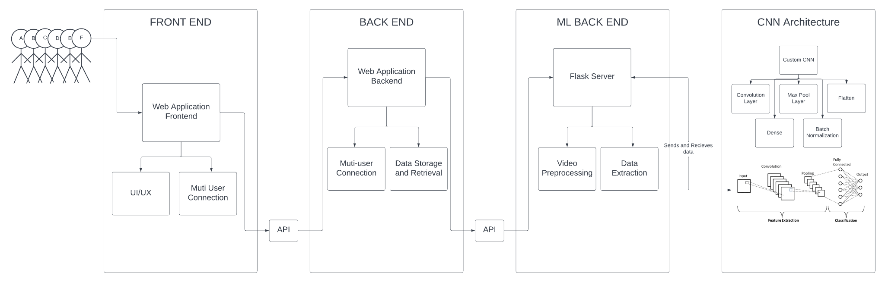

**Fig 12. Architecture Diagram**

The modules that we are attempting to integrate into our meet application, which consists of Front-end, Back-end, and Deep Learning modules, are depicted in the aforementioned image metaphorically. Different APIs will be used by our front-end, which is the meet platform, to communicate with our back-end.

Thus in this project we try to succeed in measuring the attentiveness of the student in a virtual meet.

**IV. IMPLEMENTATION**

We plan to divide the Implementation into three modules.

1. Front end

It is made up of user interface and design, using web languages like React.Js and Angular.Js, the user interface for each of them receives the most of the technical work.

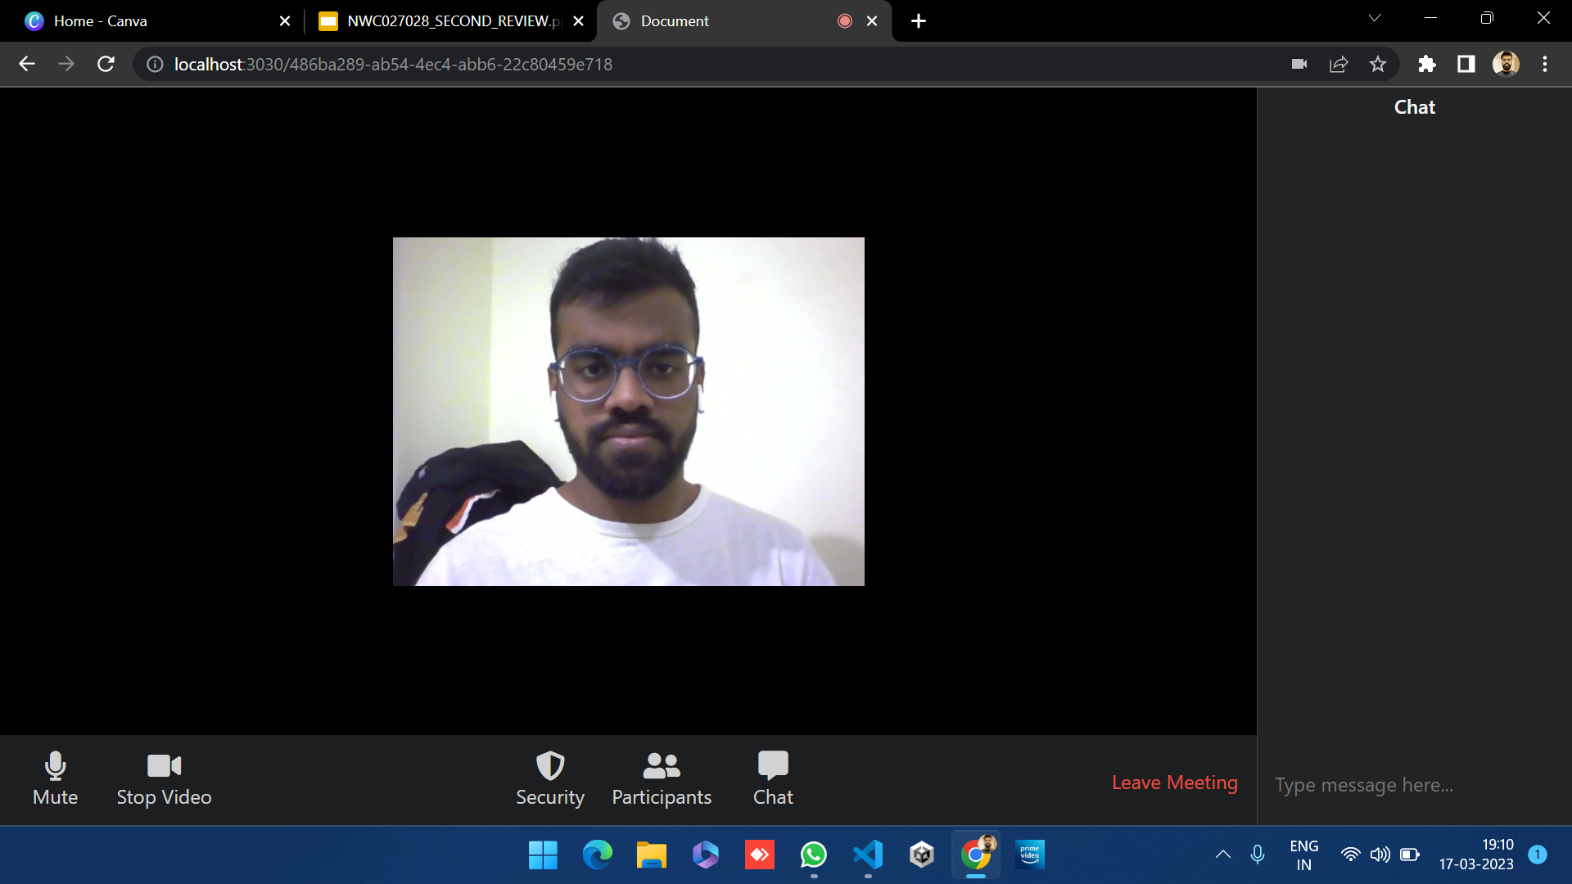

**Fig. 13 Meet Platform Interface - FrontEnd**

The user will be interacting with the platform's interface, which is depicted in the above figure. It is created using frontend tools like AngularJs and ReactJs. This process involves several stages including construction of wireframes, prototypes and ultimately user testing.

2. Backend

All the internal workings of this meet application are handled by the backend. The meet attendees have no need to interact with these modules and only the front end communicates with the backend.

We will be using the WebRTC, a Javascript Library that makes the real time communication capability in custom made applications.

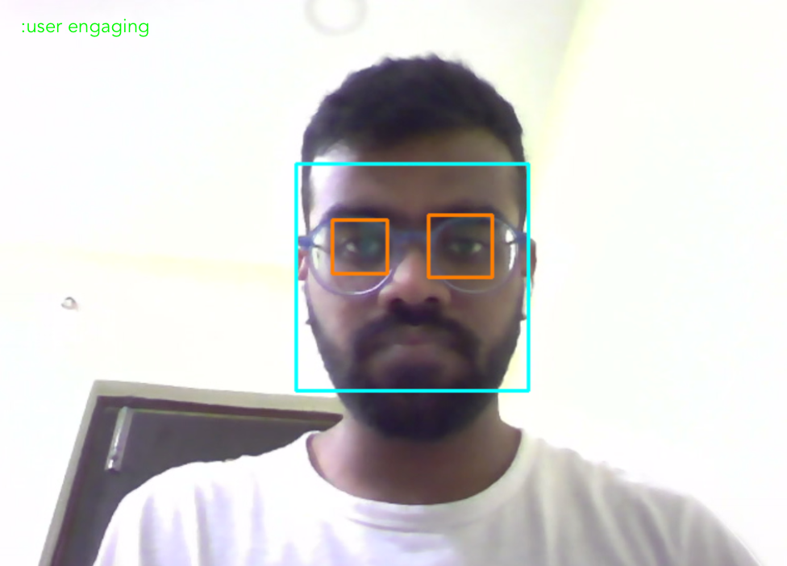

**Fig. 14 Feature Detection**

The running model for a human face's feature detection is illustrated in the above figure. Our meeting platform will integrate this model, which will aid in platform analysis.

3. Deep Learning

It is responsible for processing face data in order to detect engagement. This module is totally separated from the user in every possible way.  
 We will be implementing CNN to classify images. The convolution neural network is an intricatesystem with many moving pieces that serves three main purposes, namely convolutional, ReLU and pooling.

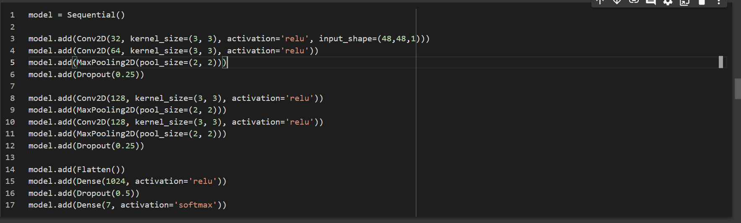

**Fig. 15 - Part of CNN using Keras framework**

This code defines a convolutional neural network (CNN) using the Keras framework. The model consists of several layers: The first layer is a 2D convolutional layer with 32 filters, each with a kernel size of 3x3, using the rectified linear unit (ReLU) activation function. The input shape of the layer is 48x48x1, meaning the input is a grayscale image with dimensions 48x48. The second layer is another 2D convolutional layer with 64 filters, also with a kernel size of 3x3 and using the ReLU activation function. A max pooling layer follows, which reduces the dimensions of the feature maps produced by the convolutional layers by taking the maximum value within a 2x2 window. A dropout layer is added to help prevent overfitting. This randomly drops out 25% of the neurons in the layer during each training epoch. Two more 2D convolutional layers follow, each with 128 filters and a kernel size of 3x3. The ReLU activation function is used for both.

Two more max pooling layers follow, each with a 2x2 window. Another dropout layer is added to further help prevent overfitting. A flatten layer is added to convert the 2D feature maps from the previous layer into a 1D vector, which can be used as input to a fully connected layer. A fully connected layer with 1024 neurons and the ReLU activation function follows the flatten layer. Another dropout layer is added to the fully connected layer.

Finally, a dense layer with 7 neurons and the softmax activation function is added to produce the output of the network. The 7 output neurons correspond to the 7 emotions that the network can recognize (neutral, happy, sad, angry, fearful, disgusted, surprised) according to which it decides if the user is engaging.

Overall, this CNN is designed to recognize emotions in facial expressions from grayscale images with dimensions of 48x48.

3.1. Convolution

By taking tiles from the input feature map and filtering them in order to calculate new features, convolution creates an output feature map also known as a convolved feature (which may have a different size and depth than the input feature map). Two parameters characterise a convolution:

i. Specifications of the selected tiles (typically 3x3 or 5x5 pixels).

ii. If more filters are used, a more detailed feature map will be produced.  
 Moving the filters, which are matrices of the same size as the tile size, over the grid of the input feature map one pixel at a time in both the horizontal and vertical directions, a convolution successfully isolates each matching tile from the input feature map.

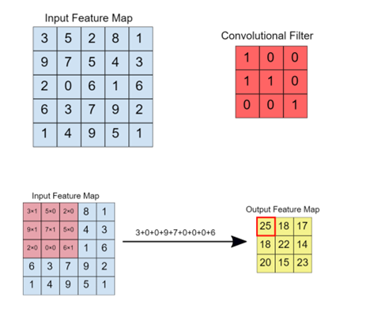

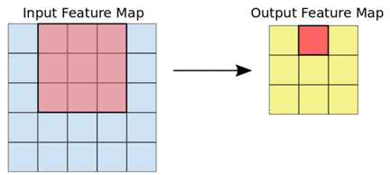

**Fig 16. Converting Input Feature to Output Feature Map and summing up the resultant matrix.**

After performing an element-by-element multiplication between the filter matrix and the tile matrix for each filter-tile pair, the CNN then sums the resulting matrix to yield a single value. The resultant values for each filter-tile pair are then output by the convolved feature matrix.

3.2. ReLU:  
 In order to provide nonlinearity to the model, the CNN performs a Rectified Linear Unit (ReLU) transformation on the convolved feature after each convolution operation. ReLU yields x for all values of x greater than zero and 0 for all values of x lower than zero.  
  
 3.3. Pooling:  
 In order to reduce the number of dimensions in the feature map (and hence speed up the processing time), the CNN downsampled the convolved feature after applying ReLU, but without losing any of the essential information about the feature. One often used technique in carrying out this process is the Max pooling algorithm.  
  
 The function that Max pooling does is similar to that of convolution. Extract tiles of a specified size by gliding the feature map left and right. The maximum value for each tile is sent to a new feature map while all other values are discarded.  
 There are two inputs needed for maximum pooling operations:

3.3.i. Maximum pooling filter size  
3.3.ii. Stride

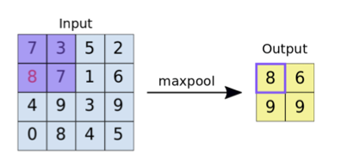

Fig 17. Depicts the procedure of max pooling

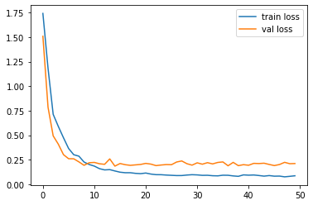

**Fig 18. Train Vs Value LossGraph**

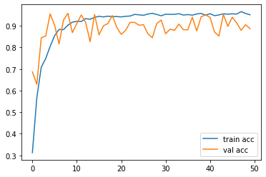

**Fig 19. Train Vs Value Accuracy Graph**

The first plot shows the training and validation loss of the model. The plt.plot() function is used to plot the training loss values from the model_info.history dictionary, which contains the loss values recorded during the training process. The label argument is used to set the legend for the plot. The same function is used to plot the validation loss values from the same dictionary, but with a different label. The plt.legend() function is used to show the legend in the plot, and plt.show() displays the plot in a window. Finally, plt.savefig() saves the plot as an image file.

The second plot shows the training and validation accuracy of the model. Similar to the first plot, plt.plot() function is used to plot the training accuracy values and validation accuracy values from the model_info.history dictionary. The label argument is used to set the legend for the plot. The plt.legend() function is used to show the legend in the plot, and plt.show() displays the plot in a window. Finally, plt.savefig() saves the plot as an image file.

Overall, these plots can help you understand how the model is performing during training and validation, and can give insight into whether the model is overfitting or underfitting.

**V. CONCLUSION AND FUTURE SCOPE**

This comparison study's concluding findings prove to be very informative. Each article that was taken into consideration for this study has its own distinct set of benefits and drawbacks. This was the result that was anticipated because pros and drawbacks are two sides of the same coin. After this comparison, we were able to decide what steps we needed to take to create a system that could detect student engagement in a completely functioning manner.

This model can be enhanced in the future to recognise more emotions than the seven it does at the moment, which would increase its real-world accuracy. In the future, this model might also be built into a whole piece of software to evaluate how well it performs in practical settings.

**Abbreviations**

CNN: Convolutional Neural Network; Js: Javascript; ReLU: Rectified Linear Unit; RTC: Real Time Communication; API: Application Programming Interfaces

**Acknowledgments**

We are thankful for the people who gave us the technical assistance in making the model and getting the data set to train the model.

**Funding**

Not applicable.

**Availability of data and materials**

As per request.

**Authors’ Contributions**

We did a literature survey on the existing models and proposed and implemented the measurement of student engagement using dataset images. Dr. TYJ NM and Dr. USK guided us in the choosing of parameters for evaluating various techniques. They approved the final version of the paper to be submitted. Both authors read and approved the final manuscript.

**Competing interests**

Dr. TYJ Naga Malleswari and Dr. Ushasukhanya declare that they have no competing interests.

**VI. REFERENCES**

| [1] | Ahmed, Zeyad Abdulhameed & Jadhav, Mukti & Al-madani, Ali & Tawfik, Mohammed & Alsubari, Saleh & Alshareef, Ahmed. (2022). Real-Time Detection of Student Engagement: Deep Learning-Based System. 10.1007/978-981-16-2594-7_26. |
| --- | --- |
| [2] | Pabba, Chakradhar & Kumar, Praveen. (2022). An intelligent system for monitoring students' engagement in large classroom teaching through facial expression recognition. Expert Systems. 39. 10.1111/exsy.12839. |
| [3] | Y. -Y. Ou, A. -C. Tsai, J. -F. Wang and P. -C. Lin, "An integrated vision system on emotion understanding and identity confirmation," 2017 International Conference on Orange Technologies (ICOT), 2017, pp. 205-209, doi: 10.1109/ICOT.2017.8336123. |
| [4] | S. Deniz et al., "Computer Vision for Attendance and Emotion Analysis in School Settings," 2019 IEEE 9th Annual Computing and Communication Workshop and Conference (CCWC), 2019, pp. 0134-0139, doi: 10.1109/CCWC.2019.8666488. |
| [5] | P. Chiranjeevi, V. Gopalakrishnan and P. Moogi, "Neutral Face Classification Using Personalized Appearance Models for Fast and Robust Emotion Detection," in IEEE Transactions on Image Processing, vol. 24, no. 9, pp. 2701-2711, Sept. 2015, doi: 10.1109/TIP.2015.2421437. |
| [6] | A. V. Iyer, V. Pasad, S. R. Sankhe and K. Prajapati, "Emotion based mood enhancing music recommendation," 2017 2nd IEEE International Conference on Recent Trends in Electronics, Information & Communication Technology (RTEICT), 2017, pp. 1573-1577, doi: 10.1109/RTEICT.2017.8256863. |
| [7] | Apicella, Andrea & Arpaia, Pasquale & Frosolone, Mirco & Improta, Giovanni & Moccaldi, Nicola & Pollastro, Andrea. (2021). EEG-based Measurement System for Student Engagement Detection in Learning 4.0. 10.21203/rs.3.rs-944837/v1. |
| [8] | Uçar, Mustafa & Özdemir, Ersin. (2022). Recognizing Students and Detecting Student Engagement with Real-Time Image Processing. Electronics. 11. 10.3390/electronics11091500. |
| [9] | Ayouni S, Hajjej F, Maddeh M, Al-Otaibi S. A new ML-based approach to enhance student engagement in an online environment. PLoS One. 2021 Nov 10;16(11):e0258788. doi: 10.1371/journal.pone.0258788. PMID: 34758022; PMCID: PMC8580220. |
| [10] | Ali Abedi, Shehroz S. Khan: “Improving state-of-the-art in Detecting Student Engagement with Resnet and TCN Hybrid Network”, 2021; [http://arxiv.org/abs/2104.10122 arXiv:2104.10122]. |
| [11] | Naga Malleswari TY, Malathi D, Vadivu G. Deduplication Techniques: A Technical Survey. International J Innovative Res Sci Technol|, 2014, 1, (7) pp. 318–325 |
| [12] | Turlapati, Malleswari & G, Dr. Vadivu & Malathi, D.. (2014). Live Virtual Machine Migration Techniques-A Technical Survey. Springer India, Intelligent Computing Communication and Devices. 308. 10.1007/978-81-322-2012-1_32. |
| [13] | Turlapati, Malleswari & G, Dr. Vadivu. (2017). Deduplication of VM memory pages using MapReduce in live migration. ARPN Journal of Engineering and Applied Sciences. 12. 1890-1894. |
| [14] | T.BHASKAR REDDY, B.MURALI DHAR NAIDU, S.USHASUKHANYA. (2020). PERSON FACE RE-IDENTIFICATION USING DEEP LEARNING APPROACH. International Journal of Advanced Science and Technology, 29(6s), 2290-2295. Retrieved from<http://sersc.org/journals/index.php/IJAST/article/view/11048> |
| [15] | Ms. Avani Dungarwal, Mrs. Ushasukhanya, Mr. Parth Jain. (2020). OPTIMIZATION OF DEEP LEARNING FOR HUMAN DETECTION. International Journal of Advanced Science and Technology, 29(6s), 1873 - 1883. Retrieved from<http://sersc.org/journals/index.php/IJAST/article/view/9350> |
| [16] | T.BHASKAR REDDY, B.MURALI DHAR NAIDU, S.USHASUKHANYA. (2020). PERSON FACE RE-IDENTIFICATION USING DEEP LEARNING APPROACH. International Journal of Advanced Science and Technology, 29(6s), 2290-2295. Retrieved from<http://sersc.org/journals/index.php/IJAST/article/view/11048> |
| [17] | Malathy C,Sadiq M.A.K, Annapurani K,”A new feature extraction technique for person identification using multimodal biometrics”, Research Journal of applied sciences,Engineering and technology,8(12),pp 1492-1497,2014 |
| [18] | Dr.Annapurani Panaiyappan, K Debanjan Bhattacharya. (2020). VPN System Tracking through Media Access Control (Mac) Address . International Journal of Advanced Science and Technology, 29(7s), 4417 - 4420. Retrieved from<http://sersc.org/journals/index.php/IJAST/article/view/25657> |
| [19] | Srikanth Redrouthu ,Annapurani.K,” Time Comparison of Various Feature Extraction of Content Based Image Retrieval”, International Journal of Computer Science and Information Technologies, Vol 5,issue 2,pp. 2518-2523, 2014 |
| [20] | Hu, Jinhua & Gu, Jianhua & Sun, Guofei & Zhao, Tianhai. (2010). A Scheduling Strategy on Load Balancing of Virtual Machine Resources in Cloud Computing Environment. Parallel Architectures, Algorithms and Programming, International Symposium on. 89-96. 10.1109/PAAP.2010.65. |
| [21] | TYJ, N.M., G, V. Adaptive deduplication of virtual machine images using AKKA stream to accelerate live migration process in cloud environment. J Cloud Comp 8, 3 (2019). |